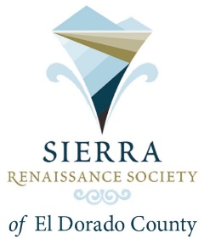

February 2026 Newsletter

It’s Dues Renewal Time for 2026.
If you haven’t renewed already, you have three options:
- Pay by check or cash at the February meeting,
- Send a check to EDCF, PO Box 1388, Placerville, Ca. 95667 by the end of February. Please make check payable to EDCF and put Sierra Renaissance Society on the memo line,
- Or go to the EDCF website and pay by credit card. The URL is listed below.

https://www.srsedc.org/

The dues are $40 for the year per member and we thank you for your support.

Link Renew your membership online

The Presentation for February 20, 2026 is Senior Health, coverings topics such as Staying in Shape, Fall Prevention, Diet as We Age, and Cognition - Keeping your Mind Sharp, and Stroke Awareness. Presenters are all from Marshall Medical, Mindy Danovaro, Dr. Teresa Montgomery, Alice Carpentier, Terryn Davis.
Mindy Danovaro, Executive Director Philanthropy for Marshall and the Marshall Foundation for Community Health is an experienced senior nonprofit executive with a demonstrated history of working with the Board of Directors to raise funds for health and wellness, higher education, and health care industries. She graduated from University of California, Los Angeles, New York Institute of Technology, and is currently an EdD Candidate in Leadership and Innovation.
Dr. Teresa Montgomery is the Senior Physical Therapist of the outpatient rehabilitation clinic at Marshall Medical Center in Placerville. She earned her Bachelor of Science degree in Exercise Biology from the University of California, Davis in 2008. In 2012, she completed her Doctor of Physical Therapy degree from the University of St. Augustine, where she completed the manual therapy program for treatment of various orthopedic conditions. Teresa joined the Marshall Medical team in 2016 and has since expanded her specialty areas to include treatment of neurologic impairments related to acquired brain injuries, progressive neuromuscular conditions and vestibular disorders. She treats adults who suffer from generalized weakness and deconditioning, impaired balance, or other gait impairments. She also works with the oncology team to help patients maintain their highest level of function during and after their cancer treatments. In 2024, she became a Certified Lymphedema and Wound Therapist (CLWT) and is now treating patients who suffer from lymphedema. She is passionate about helping patients achieve their personal goals, return to their prior level of function, and maintain their highest level of independence for as long as possible. Outside of work Teresa enjoys spending time outdoors with her husband and three children.

Alice Carpentier has been a Registered Dietitian for 34 years. She obtained her Bachelor’s in Foods and Nutrition from California State Polytechnic University, Pomona, California in 1990, with subsequent Registered Dietitian status in 1991. Her background, has been in Clinical Nutrition, working in Acute Care and Long-Term Care Acute medical facilities, implementing Medical Nutrition Therapy for patients with varied conditions, co-morbidities. She has extensive background in alternative nutrition support, as well as diet therapy for disease states, and nutrition for wound healing. She has always enjoyed the field of dietetics and helping patients as a Registered Dietitian. She is a very active individual and maintaining health in body and mind is of utmost importance to me, particularly as aging occurs.
Terryn Davis has worked in the field of Occupational Therapy (OT) for over 30 years. Her extensive experience includes serving on the head injury/neuro team in acute rehabilitation and working in outpatient therapy with individuals affected by spinal cord injury (SCI), traumatic brain injury (TBI), and cerebrovascular accidents (CVA). She is certified in Neuro-Developmental Therapy and has completed training in both Neuro-IFRAH and assistive technology, including complex power wheelchair evaluations.
Tarryn’s background also includes leadership roles, such as Director of Rehabilitation for two Skilled Nursing Facilities in the Bay Area and Regional Care Manager for ALS, where she helped develop care services across the state of Hawaii. Most recently, she has provided OT services in Level I Trauma Centers in Colorado.
In addition to her clinical work, Terryn has taught in the Occupational Therapy Assistant Program at Kapiolani Community College, an experience that has further enriched her skills as a therapist and mentor.
Outside of her professional life, Terryn enjoys racing outrigger canoes with the Capitol Outrigger Team near Folsom. She finds great joy in connecting with others, both in and out of the workplace.

Location, Mother Lode Lions Hall 4701 Missouri Flat Rd. 1-3 PM Diamond Springs

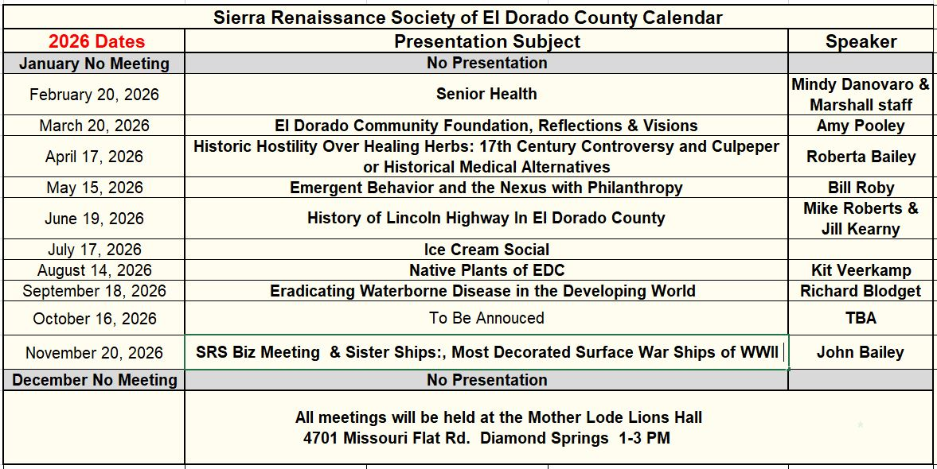

The Book Group meeting at the Placerville Main Library 345 Fair Lane, Placerville from 1-3 PM

February Book Paper Girl February 12th by Beth Macy
Paper Girl is a gift of courage, empathy, and insight. Beth Macy has turned to face the darkness of her family and community, people she loves wholeheartedly, even the ones she sometimes struggles to like. And in facing the truth—in person, with respect—she has found sparks of human dignity that she has used to light a signal fire of warning, but also of hope.

March Book The Sweetness of Water
March 12th by Nathan Harris

The Sweetness of Water by Nathan Harris is a debut novel set in post-Civil War Georgia, following newly freed brothers Prentiss and Landry as they work for a white couple, George and Isabelle Walker, who are grieving the loss of their son. The story explores themes of racism, grief, and forbidden love, particularly a secret romance between two Confederate soldiers, which brings violence and turmoil to the community. It's an Oprah's Book Club pick praised for its beautiful prose and exploration of humanity in harrowing circumstances.

What’s Happening this Month and Next

Thursday Book Group meets 1-3 PM
February 12^{h} Placerville Main Library
345 Fair Lane, Placerville

Friday Monthly Meeting
February 20th 4701 Missouri Flat Rd, Diamond Springs
Mother Lode Lions Hall 1-3 PM

Thursday Book Group meets 1-3 PM
March 12th Placerville Main Library
345 Fair Lane, Placerville
A Link to You Tube videos of previous presentations:

https://www.youtube.com/@sierrarenaissancesociety6812

A PDF of the newsletter can be found on the SRSedc.com
website at the link below:

Newsletter in PDF link

Sierra Renaissance Society is a 501(c)(3) organization.

